Lab – Post Exploitation (Exfil Data)
Ethan Perdieu

Directions: Using Kali and another Linux device attempt to evaluate different data exfiltrate techniques.

Environment Setup
- Kali attack box (VM)
- Secondly device (docker, VM… etc.). I would use ubuntu or another Debain but not required.

Living off the land (LotL) bin
- Try two different command line or shell approaches to exfil data

  - curl
  - wget
  - tar
  - gzip
  - base64
  - ssh (key)
  - nc / bash TCP redirection

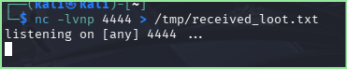
Using nc listening on Ubuntu Docker Container

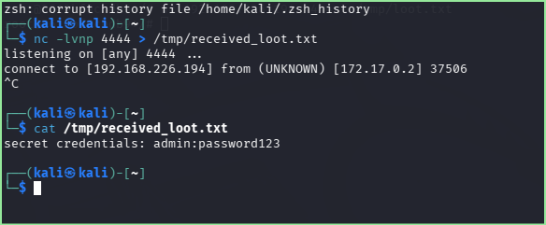

Technique 1: File successfully exfiltrated the data using NC

Evaluation Criteria | nc (Netcat)
Chance of Detection  (Low, Med, High) | High – It is unencrypted TCP traffic, so it is very easy to spot if any network monitoring is occurring
Privileged Access  (user / sudo / root) | User
Environmental Assumptions | nc is installed on both machines and there is a direct connection between the hosts
Complexity  (error prone?) | Fairly low since it is one line of code. Only thing you must be worried about is getting the IP correct and port.
Methods of Detection | Firewall logs, Pcap Analysis using Wireshark, SIEM Alerts etc.

Technique 2: Using base64 + curl
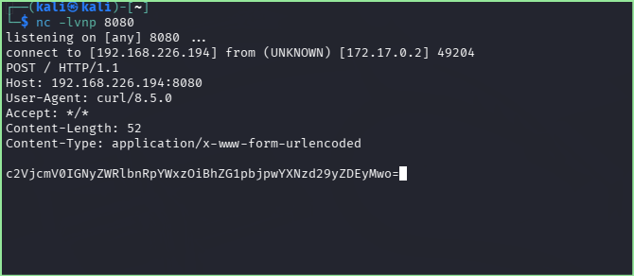

Decoding base64 data
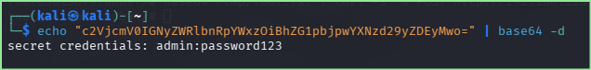

Evaluation Criteria | base64 + curl
Chance of Detection  (Low, Med, High) | Low chance of detection due to the traffic looking like normal HTTP traffic
Privileged Access  (user / sudo / root) | User
Environmental Assumptions | Curl is installed, attacker has set up a listener, and the target has HTTP access
Complexity  (error prone?) | Medium complexity because the command itself is longer and uses specific curl flags. Along with the @- syntax being a little odd
Methods of Detection | HTTP Inspection and DLP scaning

Web Server Abuse
- Pick one of the options
  - Cloud storage (Googledrive, AWS S3, Dropbox… etc.)
    - What level of sophistication are you using?
      - Are you logging into a fake account and simply uploading?
      - Are you making it a link, so anyone can edit it? Is the data plaintext or encoded?
  - Code repository like Github
I went with a personal public repo called exfil-demo to simulate an attacker pushing code to a repository. The attacker can use the repo to temporarily store the code.

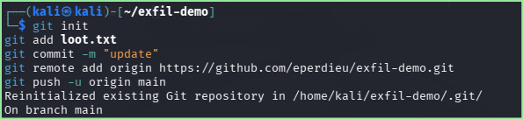

  - Social media
    - Does this have steganography?
      - If so, what was type was used and is there a password?
      - Size difference between source format and modified data format

Evaluation Criteria | Code Repository Exfiltration
Chance of Detection  (Low, Med, High) | LOW – Looks like normal GitHub HTTP Traffic, can be detected if repository is found but unlikely
Privileged Access  (user / sudo / root) | User
Environmental Assumptions | Git is installed; attacker has a GitHub account; outbound HTTPS is allowed
Complexity  (error prone?) | MED-HIGH – Git setup and authentication can have a lot of errors (I ran into a lot of errors when it came to getting the access token)
Methods of Detection | DLP monitoring tools that looks out outbound data, GitHub audit logs

Tunneling Tool
- Many options (DNS, ICMP, HTTP/HTTPS) but some may require a domain or admin rights. I would recommend staying away from Chisel, Sliver / Ligolo (C2), and obfs4 / TOR.
- Socat, custom bash, https connect, ssh
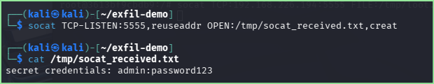
File successfully tunneling via socat (Used Ubuntu container)

Evaluation Criteria | Socat
Chance of Detection  (Low, Med, High) | MED – it is a raw TCP connection that used port 5555 which is uncommon and not a “standard” port. Can trigger firewall alerts if setup
Privileged Access  (user / sudo / root) | User
Environmental Assumptions | Socat is installed on both machines and there is direct connection between the two devices. Port 5555 must not be blocked
Complexity  (error prone?) | MED – I found the syntax less intuitive especially compared to nc.
Methods of Detection | Firewall Logs/alerts would be the most prevalent due to uncommon port

Scapy (Python)
- Create your own covert storage channel (CSC) or covert timing channel attack (CTC)
- Show evidence of successfully receiving it. This may require multiple scripts or manually doing some steps.
  - Wireshark capture to csv.
  - Recreated image

Creating sender script within kali using scapy
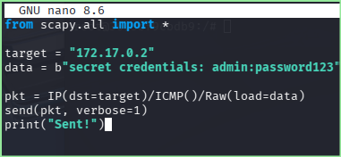

Creating receiver script within the container using scapy
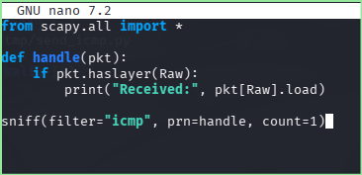

Running Script
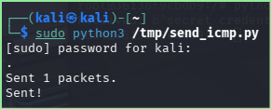
Receiving Packet
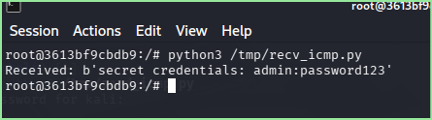
Wireshark Capture
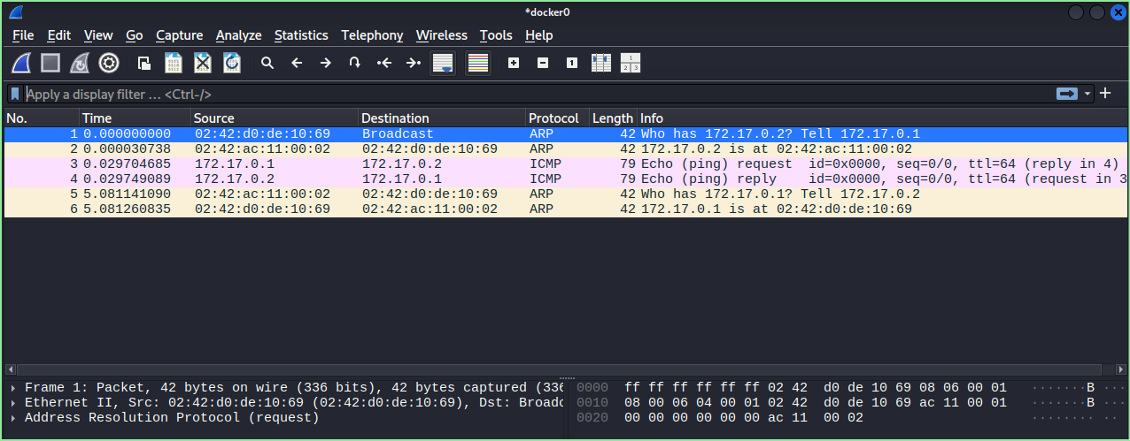

Evaluation Criteria | Scapy
Chance of Detection  (Low, Med, High) | LOW – ICMP traffic looks like a normal ping and request, if payload is discovered then it is compromised
Privileged Access  (user / sudo / root) | Root
Environmental Assumptions | Scapy is installed and ICMP is not blocked. Root access is available
Complexity  (error prone?) | HIGH – both the sender and receiver need to make a custom script to send out the payload and receive it, they were very easy to break
Methods of Detection | Packet inspection and looking at payloads, Wireshark analysis

First scrapy error during send
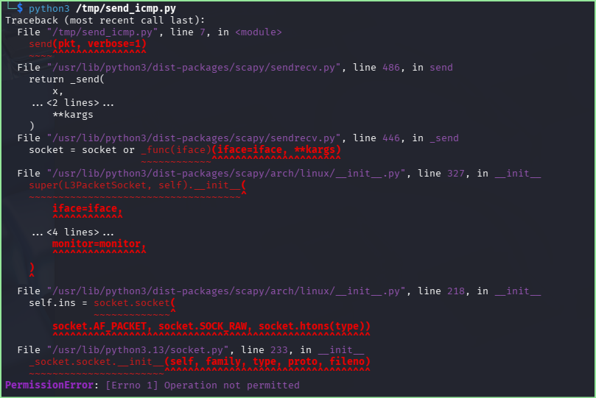

No sudo ^

References

https://linux.die.net/man/1/socat

https://linux.die.net/man/1/base64

https://scapy.readthedocs.io/en/latest/usage.html#starting-scapy

